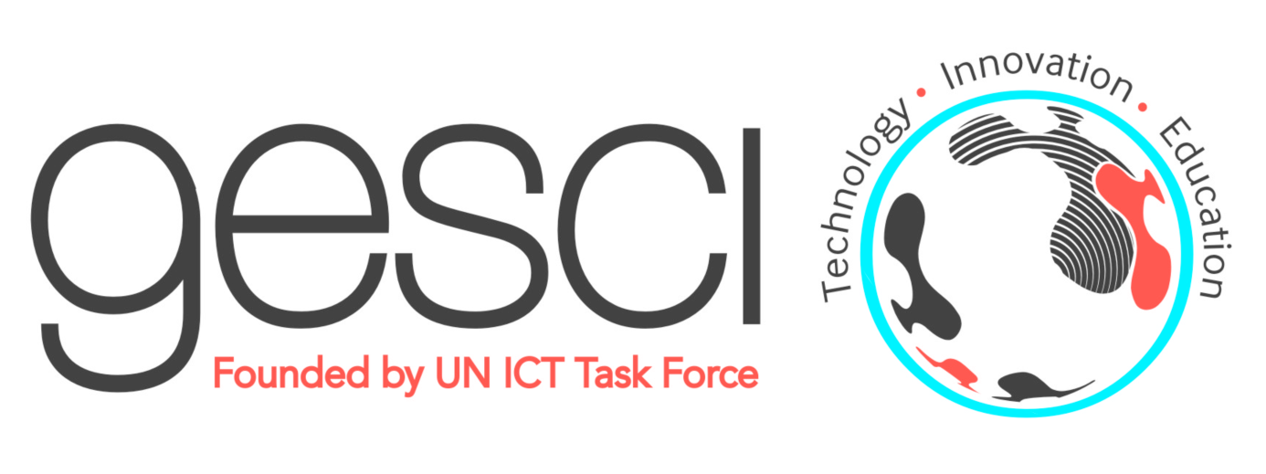
PRESS RELEASE For immediate release

GESCI and ADEA sign an agreement to boost the impact
of programs integrating ICT in education and training in Africa
Nairobi, February 15, 2016. GESCI (Global e-Schools and Communities Initiative),represented by its Chief Executive Officer, Jerome Morrissey, and the Association for the Development of Education in Africa (ADEA), represented by its Executive Secretary, Oley Dibba-Wadda, signed on January 28, 2016 the renewal of a Memorandum of Understanding (MoU) which strengthens their collaboration.
The MoU was signed in Abidjan, Côte d’Ivoire, at the headquarters of the African Development Bank Group (AfDB).
The signing took place during a graduation ceremony for senior officials who have successfully completed the Leadership in ICT and knowledge societies development programme (LaTIC), implemented by GESCI in Côte d’Ivoire in 2015.
It was witnessed by the Ambassador of the Kingdom of Morocco and the resident representatives of JICA, UNAIDS and UNESCO in Côte d’Ivoire, as well as by senior officers and managers from the AfDB, Côte d’Ivoire’s Ministry of National Education, GESCI and ADEA.
Signed for a period of 3 years, the agreement seeks to increase the impact and scope of GESCI's and ADEA's programmes. As part of the agreement:
- GESCI will ensure the coordination and technical leadership of ADEA's Task Force on ICT;
- GESCI and ADEA will jointly organise the 2nd Ministerial Forum on ICT Integration in Education;
- GESCI will contribute to the organisation of ADEA's Triennale on Education and Training in Africa, providing expertise in its fields of competence, namely ICTs and education and the development of inclusive knowledge societies;
- ADEA will present GESCI's African digital schools initiative (ADSI) to the Ministers of Education in Africa.
GESCI and ADEA will also conduct joint research activities and share their knowledge and experiences, in particular on the state of ICT integration in education and training in Africa, the role of ICTs in the development of technical and vocational skills (TVSD), and the empowerment of young people through entrepreneurship and the acquisition of new skills.
Finally, the two organisations will join forces to mobilize public and private partners to support countries in their efforts to integrate ICTs in education, to develop technical and vocational skills, and to improve research and innovation competencies in Africa.
The Global e-Schools and Communities Initiative (GESCI) is an international non-profit organization based in Nairobi, Kenya. GESCI was established by the United Nations in 2003 upon recommendation of the United Nations' ICT Task Force. The organisation supports governments in their efforts for socio-economic development, through the successful integration of ICTs for the development of knowledge societies.
The Association for the Development of Education in Africa (ADEA) is a policy dialogue forum comprising all Ministers of Education in Africa. Established in 1988, ADEA is a pan-African institution based on a partnership between African ministries of education and training and their technical partners.

For more information:
Tarek Chehidi, Senior Program Specialist, Francophone Africa and North Africa, GESCI, tarek.chehidi@gesci.org
Press contact:
- Thanh-Hoa Desruelles, Senior Expert, Advocacy, Partner Relations and Communication, GESCI,
thanh-hoa.desruelles@gesci.orgTel: + 33/(0) 4 99 43 59 22

