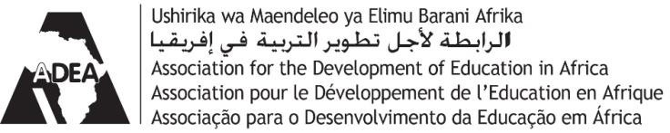

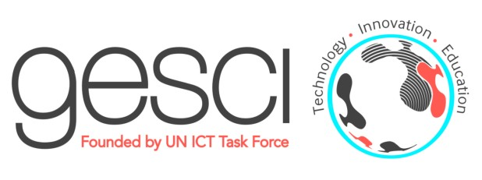
GESCI, Côte d’Ivoire and ADEA honor graduates from the ALICT programme for
PRESS RELEASE For immediate release
ICT leadership and the development of knowledge society

February 1, 2016. GESCI (Global e-Schools and Communities Initiative), the Ministry of National Education (MoE) of Côte d’Ivoire and the Association for the Development of Education in Africa (ADEA) honored last week on January 28 the participants who successfully completed the ICT leadership and development of knowledge societies (ALICT) programme offered by GESCI in Côte d’Ivoire in 2015.
The ceremony, which was held in Abidjan at the African Development Bank Group (AfDB) headquarters was attended by the Ambassador of the Kingdom of Morocco and the resident representatives of JICA, UNAIDS and UNESCO in Côte d’Ivoire, and by senior MoE, AfDB, GESCI and ADEA officials and managers.
The graduation ceremony officially handed over ALICT certificates to senior officials serving in several government ministries and universities. These include the national ministries of Education, Higher Education, Vocational Training, Health and AIDS, as well as the University of Côte d’Ivoire.
Between 2001 and 2015, the ALICT programme was implemented in 16 African countries, reaching over 500 senior officials and managers.
ALICT aims to build the capacity of leaders to be agents of change for the development of knowledge societies. In a globalized, increasingly competitive and rapidly changing world, the successful integration of ICTs and the strengthening of scientific, technological and innovation skills have become crucial to foster economic and social progress.
In his address, GESCI's Director General Jerome Morrissey congratulated the graduates and thanked both Finland's Ministry of Foreign Affairs and the African Union for supporting the ALICT programme.
He reminded GESCI's mission, which is to assist countries in their socio-economic development efforts through widespread integration of ICTs for the development of inclusive knowledge societies. "Today", he declared, "digital technologies are transforming the world: the lives of individuals, the corporate world, working environments, governments. GESCI’s tag line is 'A knowledge society for all'".
There are enormous needs in this area. Mr. Morrissey mentioned in this regard the "World Development Report 2016: Digital Dividends", just published by the World Bank Group. The report notes that “The benefits of the rapid digital expansion have been skewed towards the wealthy, skilled and influential around the world, who are better positioned to take advantage of the new technologies”. The report further states that although the number of Internet users worldwide has more than tripled since 2005, four billion people still lack access to the Internet.
"We must make every effort to make sure that new technologies benefit developing countries and facilitate their growth", Mr. Morrissey said.
ALICT diplomas were officially presented by GESCI's Director General, by the deputy director of Cabinet of Côte d’Ivoire’s Minister of National Education, Mr. Raoul Kone, and by ADEA's Executive Secretary, Mrs. Oley Dibba Wadda.

An award was also presented to the best achiever ALICT graduate for Côte d’Ivoire, Mr. Waidi Gbadebo. “I am a teacher and a scientist and I appreciated the ALICT course and its effective teaching approach. I hope to be able with my ALICT peers to contribute to Côte d’Ivoire and Africa’s development”.

Mr. Kone announced the launch of a new project in Côte d’Ivoire for the integration of ICTs in education. Implemented by GESCI, the African Digital Schools Initiative (ADSI) aims to improve the learning of science, technology, engineering and mathematics (STEM) in secondary schools through the professional development of teachers and the use of ICTs. The ADSI initiative will use the innovative ICT integration model for the teaching and learning of STEM, tested and validated by the SIPSE project (Strengthening Innovative Practice in Secondary Education) and implemented by GESCI in 20 secondary schools in Kenya and Tanzania between 2013 and 2015.

The ceremony was also the occasion for ADEA and GESCI to sign the renewal of their Memorandum of Understanding, which aims to strengthen their cooperation in order to increase the scope and impact of their programmes and activities.
ADEA's executive secretary said: "Recognizing the centrality of technology in the sustainable development of Africa, ADEA has consecrated the third strategic goal of its medium-term plan (2013 to 2017) to the strengthening of ICTs as a means to improve education and training results." She added that ADEA's ICT Task Force had just been entrusted to GESCI.
Finally, ADEA and GESCI announced two events to be held continent-wide:
- The Second Ministerial Forum on the Integration of ICTs in education, jointly organized by ADEA and GESCI, which will be held in 2016.
- The ADEA Triennale on Education and Training, which will take place in 2017 in Morocco.
The Ministerial Forum on the Integration of ICTs in education will continue the dialogue that was started in 2013 between ministers, ICT development experts, the private sector, civil society and development partners. The theme of the second edition will address the role of leadership and ICTs in education and focus on training as a key element for the development of knowledge societies and socio-economic transformations in Africa.
The ADEA Triennale is a major international event on education and training in Africa. The theme of the next Triennale will be: "Revitalizing Education towards the 2030 Global Agenda and Africa’s Agenda 2063".

About GESCI
The Global e-Schools and Communities initiative (GESCI) is an international non-profit organisation based in Nairobi, Kenya. GESCI was founded in 2003, on the recommendation of the United Nation's Task Force on ICTs. GESCI's mission is to assist governments in their efforts to promote socio-economic development, through the successful and widespread integration of Information and Communications Technologies (ICTs) for the development of knowledge societies. For more information please visit: www. gesci.org

About ADEA
The Association for the Development of Education in Africa (ADEA) is a forum for policy dialogue, composed of all the 54 Ministers of Education in Africa. Established in 1988 as a framework for better coordination among development agencies, ADEA is a pan-African institution built on a genuine partnership between African ministries of education and training and their technical and external partners. For more information please visit: www.adeanet.org

For more information:
- Tarek Chehidi, Senior Programme Specialist, Francophone Africa and North Africa, GESCI, tarek.chehidi@gesci.org
-Senthil Kumar, ALICT Programme Manager, GESCI, senthil.kumar@gesci.org
- Shem Bodo, Senior Programme Officer , ADEA, s.bodo@afdb.org
- Ramata Almamy Mbaye, Senior External Relations and Strategic Partnerships Officer, ADEA, m.mbaye@afdb.org
Press contacts:
- Thanh Hoa Desruelles, Senior Specialist, Advocacy, Partner Relations and Communication, GESCI, thanh-hoa.desruelles@gesci.orgTel: + 33 /(0) 4 99 43 59 22
- Stefano De Cupis, Senior Communication Officer, ADEA, s.decupis@afdb.org, Tel: +225 2026 5559

